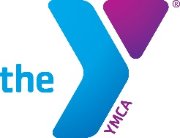
STRONGER TOGETHER

July 19, 2022
Dear Members,
As we enter the second half of 2022, I want to thank you for being an important part of the Attleboro Norton YMCA and our continued efforts to strengthen community. I am proud to have joined such a vibrant organization that is stronger together!
You belong to so much more than a gym. You are part of a cause-driven organization with a mission anchored
in youth development, healthy living, and social responsibility. As a valued member of our community, we look forward to helping you reach your personal goals in 2023!
Whether you are a parent with a child enrolled in our early education programs, a participant in our group fitness classes, or are just starting your journey with us, the Y is dedicated to fostering a sense of belonging.
We continue to evaluate and make improvements to our programs and services so members can learn, grow, and thrive. Recent efforts have included: the installation of air conditioning in the Fuller and Tappan Gyms; fitness equipment upgrades in Reilly Gym (scheduled to arrive in August); enhanced programming and space
for teens, including the addition of a staff member dedicated to teen engagement; the addition of our Attleboro
Y Rewards program; and, the expansion of operating hours on Sundays. At our Norton Outdoor Center,
we added our 5,000 sq. ft., indoor, multi-use Fred M. Roddy Children’s Pavilion, as well as a new playground.
Finally, we are currently evaluating the timeline and scope for use of our Pleasant Street Branch.
We have begun strategic planning efforts to evaluate even more ways we can continue to provide you with excellent programs and services. You’ll be receiving a member survey in August to support these efforts.
Over the past several years, we have worked hard to maintain stable membership rates. In fact, where many organizations experienced increased rates, our rates remained unchanged. To continue improving our level
of service, a modest increase is required and will take effect October 1, 2022.
Please take a few moments to review our Membership Rates, included with this letter. If you are enrolled in our monthly automated draft program, your new rate will be realized on either the 1st or the 15th of October. If you pay annually, you will be invoiced accordingly when your membership is up for renewal. If you find that you now qualify for a lesser rate, based on your household size and income, please contact Andrea Champagne, Downtown Branch Executive Director, at achampagne@attleboroymca.org or (508) 409-0766.
On behalf of our Board of Directors, staff and volunteers, thank you for being a part of our Y’s past, present,
and future.
In community and partnership,
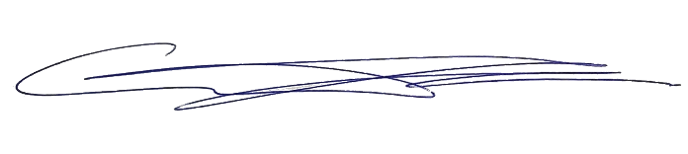
Courtney Harrness
Chief Executive Officer
P.S. If you have any questions or feedback, please contact Leigh Fontes, COO, at lfontes@attleboroymca.org.

